Mathematical Axiom

🌟 Definition
# Source: AI Source: Provided by: [Data Path: Persons Table -> ID Column: 1, Name_En Column: Motasem Essam] -> From: [ChatGPT] on [5/29/2026]
A mathematical axiom (also called a postulate) is a fundamental statement that is accepted as true without proof and used as a starting point for building a mathematical theory.
Axioms are the basic assumptions from which definitions, theorems, and proofs are developed.

🎯 Purpose of Mathematical Axioms
# Source: AI Source: Provided by: [Data Path: Persons Table -> ID Column: 1, Name_En Column: Motasem Essam] -> From: [ChatGPT] on [5/29/2026]
- Provide the foundation of a mathematical system
- Establish basic truths and assumptions
- Serve as starting points for logical reasoning
- Enable the development of theorems and mathematical theories
- Ensure consistency within a mathematical framework

📚 Characteristics of an Axiom
# Source: AI Source: Provided by: [Data Path: Persons Table -> ID Column: 1, Name_En Column: Motasem Essam] -> From: [ChatGPT] on [5/29/2026]
A mathematical axiom is:
- Accepted without proof
- Considered self-evident or assumed within a system
- Used to derive other mathematical results
- Consistent with other axioms in the same system
- Fundamental to a mathematical theory

🧩 Examples of Mathematical Axioms

Example 1: Equality Axiom
# Source: AI Source: Provided by: [Data Path: Persons Table -> ID Column: 1, Name_En Column: Motasem Essam] -> From: [ChatGPT] on [5/29/2026]
If two quantities are equal to the same quantity, then they are equal to each other.

Example 2: Reflexive Property
# Source: AI Source: Provided by: [Data Path: Persons Table -> ID Column: 1, Name_En Column: Motasem Essam] -> From: [ChatGPT] on [5/29/2026]
Every object is equal to itself.
$$a=a$$

Example 3: Euclidean Geometry Axiom
# Source: AI Source: Provided by: [Data Path: Persons Table -> ID Column: 1, Name_En Column: Motasem Essam] -> From: [ChatGPT] on [5/29/2026]
Through any two distinct points, there exists exactly one straight line.

Example 4: Set Theory Axiom
# Source: AI Source: Provided by: [Data Path: Persons Table -> ID Column: 1, Name_En Column: Motasem Essam] -> From: [ChatGPT] on [5/29/2026]
The axioms of set theory define how sets can be formed and related.

🔗 Relationship to Other Mathematical Concepts
# Source: AI Source: Provided by: [Data Path: Persons Table -> ID Column: 1, Name_En Column: Motasem Essam] -> From: [ChatGPT] on [5/29/2026]
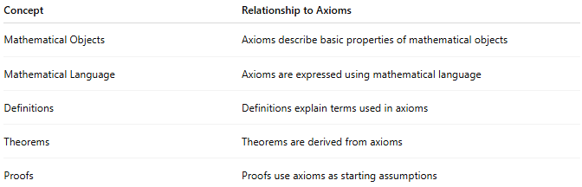
Concept | Relationship to Axioms
Mathematical Objects | Axioms describe basic properties of mathematical objects
Mathematical Language | Axioms are expressed using mathematical language
Definitions | Definitions explain terms used in axioms
Theorems | Theorems are derived from axioms
Proofs | Proofs use axioms as starting assumptions

📖 Definition vs. Axiom vs. Theorem
# Source: AI Source: Provided by: [Data Path: Persons Table -> ID Column: 1, Name_En Column: Motasem Essam] -> From: [ChatGPT] on [5/29/2026]
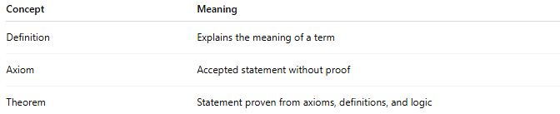
Concept | Meaning
Definition | Explains the meaning of a term
Axiom | Accepted statement without proof
Theorem | Statement proven from axioms, definitions, and logic
Example
Definition:
A triangle is a polygon with three sides.
Axiom:
Through any two distinct points, there is exactly one straight line.
Theorem:
The sum of the interior angles of a triangle is 180° (in Euclidean geometry).

🏛 Role in Mathematics
# Source: AI Source: Provided by: [Data Path: Persons Table -> ID Column: 1, Name_En Column: Motasem Essam] -> From: [ChatGPT] on [5/29/2026]
Axioms form the foundation of many mathematical systems, such as:
- Euclidean Geometry
- Non-Euclidean Geometry
- Set Theory
- Arithmetic
- Algebra
Different sets of axioms can produce different mathematical systems.

🧭 Summary
# Source: AI Source: Provided by: [Data Path: Persons Table -> ID Column: 1, Name_En Column: Motasem Essam] -> From: [ChatGPT] on [5/29/2026]
A mathematical axiom is a basic statement accepted as true without proof. It serves as a foundation for a mathematical system, allowing mathematicians to define concepts, construct proofs, and derive theorems through logical reasoning.

